Internet Programming Lab
Lab Report
Task 2 & Task 3

Student Name: | Michael Maged
Student ID: | 22P0005
Date: | 15/2/2026

Table of Contents

Task 2: Portfolio Website
2.1 Objective
2.2 Features
2.3 Screenshots
2.4 GitHub Repository
Task 3: Calculator Application
3.1 Objective
3.2 Features
3.3 Screenshots
3.4 GitHub Repository

TASK 2
Portfolio Website
GitHub Repository
GitHub Repository: https://github.com/Michael-Maged/IP-Labs

2.1 Objective
Build a responsive personal portfolio website using HTML and CSS. The page presents the developer's profile, highlights projects, and provides a contact form — all structured with semantic HTML5 elements.
2.2 Features
- Responsive navigation bar with smooth anchor links (About, Projects, Contact)
- Hero header displaying name and professional titles
- About Me section with a brief personal bio
- Projects grid showcasing three project cards
- Contact form with name, email, and message fields
- Footer with copyright notice
2.3 Screenshots
Insert screenshots of your portfolio website below. Capture at least: the full page, the projects grid, and the contact form.

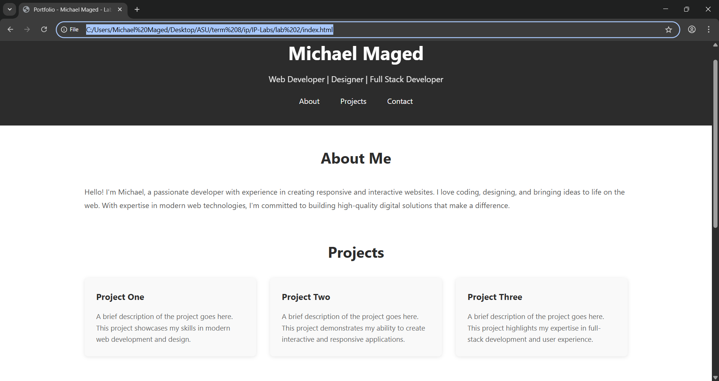

TASK 3
Calculator Application
GitHub Repository
GitHub Repository: https://github.com/Michael-Maged/IP-Labs
3.1 Objective
Develop a fully functional browser-based calculator using HTML, CSS, and vanilla JavaScript. The calculator supports basic arithmetic operations, chained calculations, percentage conversion, and division-by-zero error handling.
3.2 Features
- Digit input with leading-zero prevention
- Decimal point input with duplicate-dot guard
- Four arithmetic operators: addition, subtraction, multiplication, division
- Chained operations — pressing an operator mid-calculation triggers auto-evaluation
- Percentage conversion (÷ 100)
- Double-zero shortcut button (00)
- Division-by-zero protection (displays 'Error')
- Clear (AC) button resets all state
3.3 Screenshots
Insert screenshots of your calculator application below. Capture at least: the default state, a calculation in progress, and the error state.

